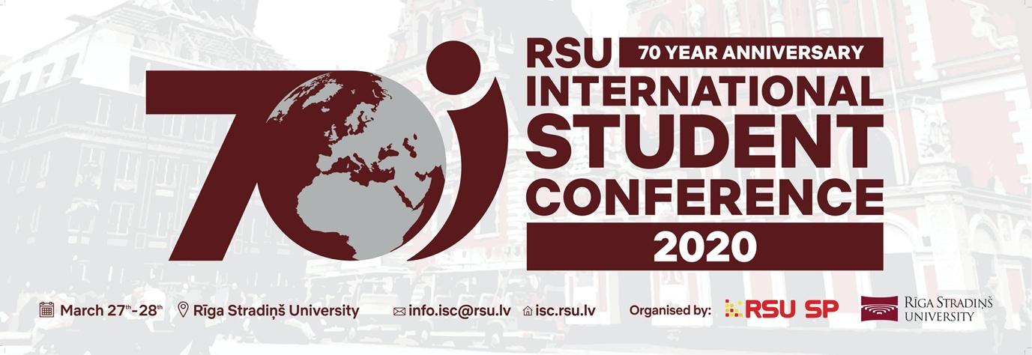

Join the biggest student conference in the Baltics!

The upcoming Riga Stradiņš University International Student Conference in "Health and Social Sciences" 2020 will be held on 27th-28th March, 2020 at Riga Stradiņš University, Dzirciema Street 16 in Riga, Latvia.
Next year’s conference will mark the 6th time we welcome not only local but also international students from all over the globe to participate with their wide range of scientific research in various fields.
Both local and international students will participate with their research in various Health and Social science sessions. RSU ISC 2020 is not just any regular conference, it is organised by students for students with the aim of promoting student research and establishing Latvia as the center of student research activity in the Baltics. Throughout these two days the conference will be a stimulating venue for experience exchange and give students the opportunity to broaden their social and scientific network.
The scientific programme includes oral, poster and case report sessions. Students have the opportunity to present in front of an international jury of field experts. Along with these student sessions there will be fascinating keynote lectures, plenary sessions and new and innovative hands-on workshops. Next year, RSU ISC 2020 is also hosting a series of fascinating events, including a hackathon and mock-trial, opening doors to new interdisciplinary opportunities for our participants. Along with a rich scientific programme Student Conference also have an interesting social programme, filled with different activities, for example - tours and trips- giving participants the chance to get to know and enjoy their time with each other.
Riga Stradiņš University International Student Conference would love to share this experience with you!
More information:
Homepage: isc.rsu.lv
Facebook: @isc.rsu.lv
Instagram: @rsu.isc

